📂 Types of Wi-Fi Frames
# Source: Chatgpt (GPT‑5 Mini) at [12/14/2025]
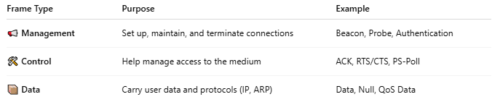
Frame Type | Purpose | Example
📢 Management | Set up, maintain, and terminate connections | Beacon, Probe, Authentication
🛠 Control | Help manage access to the medium | ACK, RTS/CTS, PS-Poll
📦 Data | Carry user data and protocols (IP, ARP) | Data, Null, QoS Data

